INSERT SCHOOL LOGO

INSERT SCHOOL ADDRESS

Groupcall Xpressions
View your child’s information on your mobile or desktop
An exciting new service is now available to help make home-school communication easier, more effective and more accessible. Groupcall Xpressions is created, supported and maintained by the award-winning school communication company Groupcall Limited.

Xpressions is completely free of charge to you and can be installed on your mobile phone or tablet. It supports both Apple iOS and Android devices. Alternatively, you can visit xpressions.groupcall.com from any internet browser on your computer, laptop or mobile device.

If you have children in different schools and those schools also use Groupcall Xpressions, you will be able to view information on multiple children within the same app and same login.

What do I need to do now?
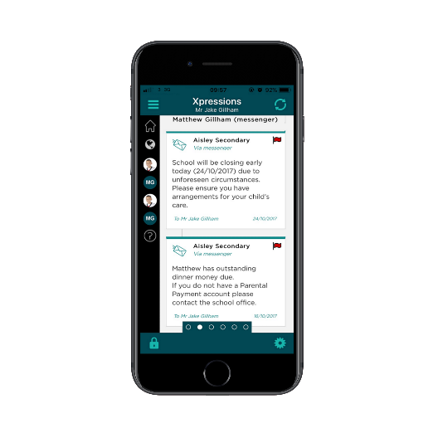
It is vital we have your correct mobile number and email address on our school database to ensure you can use Xpressions as soon as it is available. You will need these as well to log into Xpressions – we do not issue you username or passwords! Forms are available from the school office to check and update your details or simply email them to the school. You’ll need to make sure you keep these details up to date in future to maintain access to the service.
What happens next?
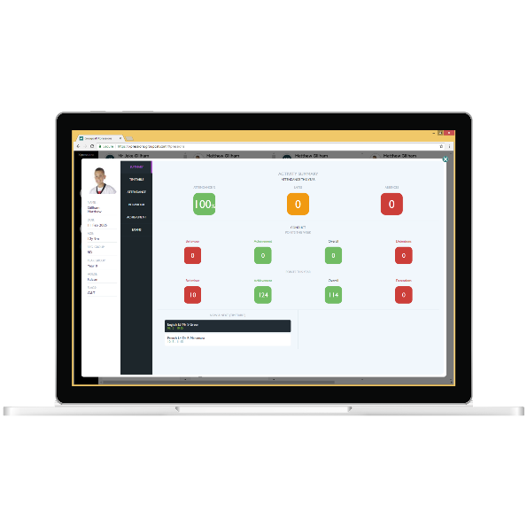
Groupcall have to set up the system for the school. Once that is complete we will let you know how to get started and log in to access your child’s information.

Once set up, you will be able to see some or all of the following information depending on the school’s system:

- Free messages sent by the school delivered directly to your Xpressions
- Updates regarding selected partner systems, used by the school such as homework, catering and library systems where applicable
- Attendance records and absences*
- Marks and grades*
- Achievement records*
- Behaviour events*
- Timetable*
- School calendar*
- Assessments and exams*
- Notification timeline for all of the above.
*Enhanced Service, using SIMS in school

