The NEW Groupcall Xpressions App
Xpressions is evolving. The Xpressions app has been rebuilt from the ground up to deliver a better, faster, more reliable experience for you as a parent. Groupcall, the company behind Xpressions, have listened to parents’ feedback and made the app simpler to use as well as making school information easier to find.

The login process, receiving notifications and accessing the app all remain the same. The app is an upgrade to the existing one, and will update just like any app (either automatically or on request, depending on your own settings).
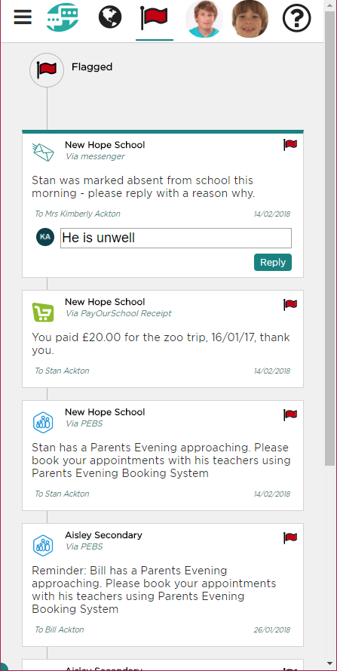
The Upgrade

Xpressions is made up of two parts, the app and the screens inside the app – and both are being upgraded.

This new app will hit the stores in the next couple of weeks (March 2018), and a couple of days later the screens inside the app will too. During this time, you can continue to use the app as normal – you may find some duplication (two ways of seeing things, the old way and the new way) for this short time while everything is put in place – this is only temporary!

What do I need to do?

If you are already using Xpressions – nothing! Just keep using the app as normal. Once the upgrade takes place, you will see a short introduction to the new look.

If you are no longer using the app this might be the perfect time to try again with the improvements now in place.

Remember that the school must have your up-to-date contact information in order for you to be able to log-in to Xpressions.

Don’t forget…

You can also access Xpressions on the web at:
https://xpressions.groupcall.com

