INSERT SCHOOL LOGO

INSERT SCHOOL ADDRESS

Groupcall Xpressions App
View your child’s information on your mobile phone!
An exciting new service is now available for parents to ensure communication between the school and yourselves is easier and more effective. Groupcall Xpressions is a service created by the award-winning school communication company Groupcall Limited.

The app is completely free of charge to you and can be installed on your mobile phone or tablet. It currently supports both Apple iOS and Android devices and you’ll be able to see information for your children. You can also login on a web browser at https://xpressions.groupcall.com

If you have children in different schools and those schools also use Groupcall Xpressions, you will be able to view information on multiple children within the same app.

What do I need to do now?
Please ensure we have your correct mobile number and email address on our school database to ensure you can use the new app as soon as it is available. Forms are available from the school office to check and update your details or simply email them to the school. You’ll need to make sure you keep these details up to date in future to maintain access to the service.
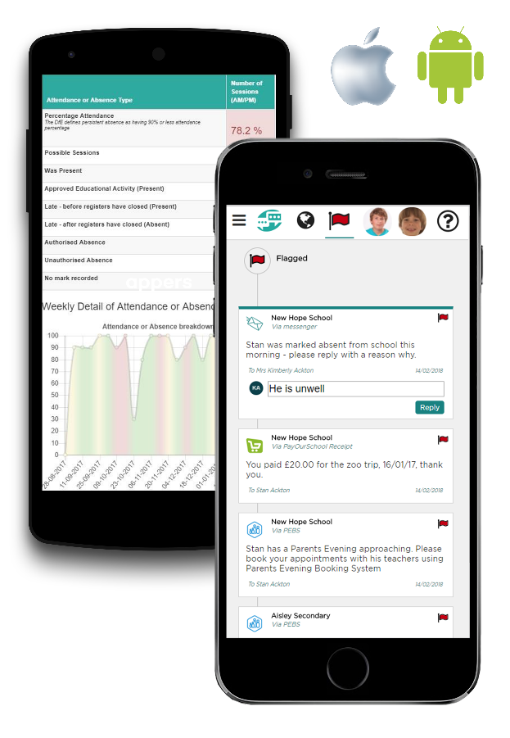
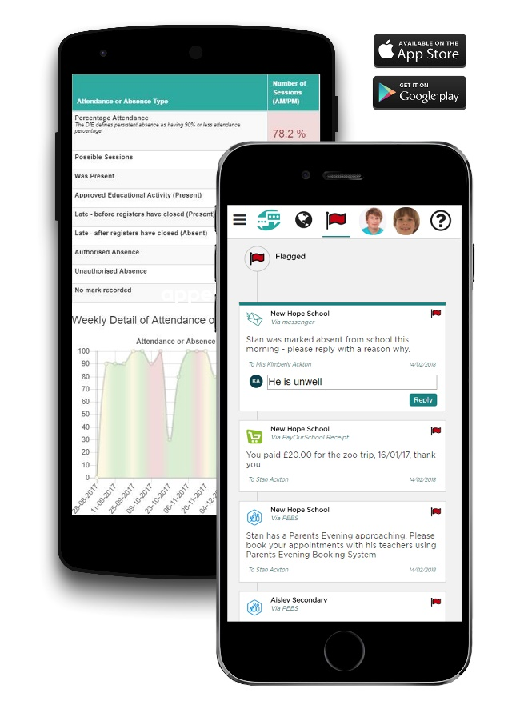
What happens next?
Groupcall have to set up the system in school. Once that is complete you can install the app and login in order to get access to your child’s information.

Once installed and set up you will be able to see some or all of the following information depending on the school’s system:

- Free messages sent by the school delivered directly to the app
- Updates regarding selected partner systems, used by the school such as homework, lunch topups and survey systems
- Attendance records and absences*
- Marks and grades*
- Achievement records*
- Behaviour events*
- Timetable*
- School calendar*
- Exams Timetable*

*Enhanced Service

Groupcall provide a dedicated support website for parents to also help you get up and running with Xpressions, or answer any common questions parents have on using the app: http://parents.groupcall.com

